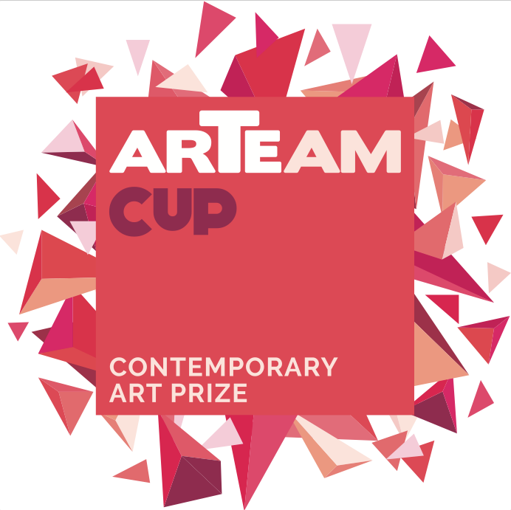
FINZIONI
GIORGIO TENTOLINI
curated by Alessandra Redaelli

Opening: THURSDAY, JUNE 15 2017, from 6 pm to 9 pm
Dates: June 16 – August 5 2017
Location: PUNTO SULL’ARTE, Viale Sant’Antonio 59/61, Varese
0332 320990 I info@puntosullarte.it
Visiting Hours: Tuesday - Saturday: h 10 am – 1 pm and 3 pm – 7 pm
Catalogue: Vanilla Edizioni, critical text by ALESSANDRA REDAELLI

Winner of “Special Price PUNTO SULL’ARTE” at the Arteam Cup 2016, GIORGIO TENTOLINI is the protagonist of a solo exhibition at the PUNTO SULL’ARTE Gallery in Varese – OPENING JUNE 15 from 6 pm to 9 pm.
Tireless experimenter, the artist moves between the classic configuration of the subject (figures, naked, faces, floral elements) and a subtle conceptual played through the choice of innovative materials. Like the metal net, which he carves by hand and stratifies to create astonishing chiaroscuro effects. The visual sensation is puzzling, since the image is clearly perceived by distance, whereas by approaching it loses its contours, it blends, thus letting the material to prevail. Moreover, his stratified paper works are enchanting, delicate floral subjects realized through the overlapping technique and played upon subtle light shades.
GIORGIO TENTOLINI: Born in Casalmaggiore (Cremona) in 1978. He studied Graphic Arts at the Arts Institute Toschi in Parma and graduated in Design and Communication at “Università del Progetto” in Reggio Emilia. After internships with artists like Marco Nereo Rotelli, he began a personal research with photographic installations, obtaining significant art prizes. Each of his works stems from a specic research on Time as memory and identity, in a careful and slow reconstruction that takes place with the study of light and etching of layers of different materials as fabric, paper, PVC. Tulle, wire mesh and masking tape are the current medium of his research for the meditative levity that they put into the image, a metaphor of places and memories, dreams and visions. A pictorial work which crosses the frontier of reality of sculpture. Tentolini lives and works in Casalmaggiore, Reggio Emilia and Milan.

