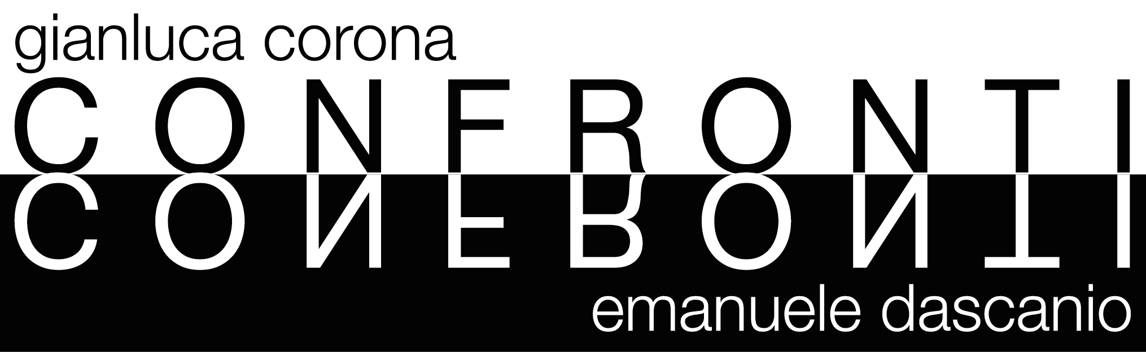

Opening: SATURDAY 19th NOVEMBER 2016, from 6 to 9 pm
Dates: 20 November – 30 Dicember 2016
Location: PUNTO SULL’ARTE, Viale Sant’Antonio 59/61, Varese 0332 320990 I info@puntosullarte.it
Visiting Hours: Tuesday – Saturday: 10 am-1 pm and 3-7 pm. Sunday: 3-7 pm

The opening of the exhibition COMPARISONS. Dialogue upon Still Life at PUNTO SULL’ARTE Gallery in Varese is on Saturday 19th November from 6 to 9 pm.

Two different and parallel glances upon still life from two artists who crossed their paths (EMANUELE DASCANIO has been GIANLUCA CORONA’s apprentice for a while) and who share the same space within this exhibition relying on oil painting, Corona, and to the pencil and charcoal chiaroscuro, Dascanio.
Within the works by Corona the fruit, the flowers and the vegetables are sharply represented within rarefied, indefinable and timeless atmospheres, aligned as if they were an homage to the theories of bottles by Morandi. The personalization of the object is made tangible through a tacit expressivity, within a sort of emotionality provided by the artist through the framing, the choice of unusual fruits and vegetables or by focusing upon imperfection, like a rut left by a beak. A suggestion of portrait which Dascanio stresses by plunging the object within a dark and indefinable space, then making it emerge as if it were made of light. The split coconut indecently shows us its pulpy heart – like the floating lemon -, it seems in the middle of a stage, flooded by a spotlight, thus almost speaking and declaiming; while light crosses the leaves sculpting pores and veining or turns into an abstract sculpture as a tangle of cellophane.

EMANUELE DASCANIO: Young master of hyperrealism, he realizes incredibly detailed paintings, mainly portraits and still life, through pencil and charcoal. He was born in Garbagnate Milanese in 1983. After graduating at the Arts High School Lucio Fontana in Arese, in 2003 he enrolled at the Academy of Fine Arts of Brera, painting section, then leaving it after only six months. However, constantly feeling the need for an artistic growth, in 2007 he arrived at Gianluca Corona’s workshop, finding a master and learning oil painting. Through the use of ancient renaissance techniques, applied to the contemporary sense of photorealism, Dascanio tries to investigate the deepest sense of reality through its own skin. He participated to various national and international competitions and collective exhibitions, always ranking among the first ones. His works belong to prestigious private collections in Italy and abroad.

GIANLUCA CORONA: Born in Milan in 1969. In 1991 he graduated at the Academy of Fine Arts of Brera in Milan. From 1994 to 1996 he frequented Mario Donizetti’s workshop in Bergamo. He then started his professional activity becoming an exponent of the young Italian depiction. His work offers a contemporary rereading of the still life and portrait genres, inspired by the great past masters. Special attention is devoted to using traditional materials and techniques. He exhibited within numerous expositions in Italy and abroad and his works are conserved within public and private collections. He lives and works in Milan.

