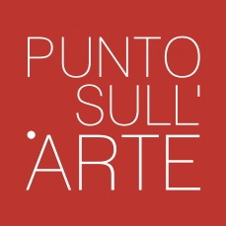
INTERNATIONAL
CONTEMPORARY ART
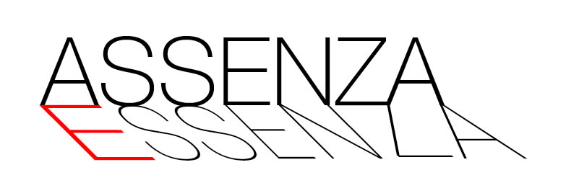

MATTEO MASSAGRANDE – JOHANNES NIELSEN – PAOLO QUARESIMA
curated by Alessandra Redaelli

Opening: march 22, 2014, h 6 pm
Period: march 22 – may 3, 2014
Location: PUNTO SULL’ARTE, Viale Sant’Antonio 59/61, Varese
0332 320990 I info@puntosullarte.it I www.puntosullarte.it
Visiting hours: tuesday - friday: 3-7 pm saturday: 10 am – 1 pm and 3-7 pm
march 23 and 30: 3 – 7 pm
Catalogue: critical texts by Alessandra Redaelli; PUNTO SULL’ARTE Edition
In collaboraztion with: Galleria FORNI, Bologna | Galleria d’Arte NINO SINDONI, Asiago
Galleria NUOVOSPAZIO Arte Contemporanea, Piacenza

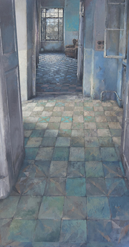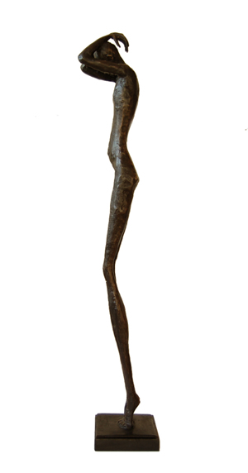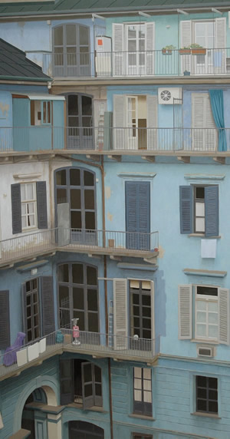

Varese will host for the first time, thanks to the PUNTO SULL’ARTE gallery, the canvas and figures by MATTEO MASSAGRANDE -one of the most valued italian figurative painters alive - and PAOLO QUARESIMA - who participated at every edition of ArteFiera Bologna since 2008 - together with the bronzes by JOHANNES NIELSEN, a swedish sculptor living in China, exclusively represented by the Gallery since 2011.

The huge exhibition, a triple solo show, entitled ABSENCE ESSENCE, is curated by Alessandra Redaelli and will inaugurate on saturday March 22 from 6 to 9 pm (with a presentation at 7 pm).

Absence intended as added value, rather than lack. As a space to be filled with whispers and deep voices, where essence can be found. As in the rooms by MATTEO MASSAGRANDE (Padua, 1959), scenarios whose void, framed between ancient walls and floors and huge windows is vivid and dense. Filled of distant echoes, forgotten voices, memories and nostalgia, shadows and fogs, a past which denies to be dismissed.
In the same way, within PAOLO QUARESIMA’s (Merano, 1962) glimpses human absence becomes material through the traces of his passage. These traces become stylish games scanned into pulpy chrome platings, lke scores of space perfectly balanced.
As in the bronze sculptures by JOHANNES NIELSEN (Falkenberg, Sweden, 1979), completely intact in their nudity, ascetic essences of bodies which become soul, aiming at pure spirituality.

MATTEO MASSAGRANDE: Born in Padua in 1959. He started his exhibitions in 1973 taking part in group and solo shows and contests all around Italy and obtaining various rewards from the beginning. Along with his painting activity, he developed the graphic one since 1974, whose results are now part of prestigious art exhibitions. Recently some of his ethcings became part of the Gabinetto delle Stampe of the Uffizi in Florence. He was chosen for more than one hundred solo exhibition in Italy and abroad. His works are exhibited in various museums, churches, private and public collections. He lives in Padua, splitting his activity between his local atelier and the one in Hajos (Ungary).
Courtesy Galleria d’Arte NINO SINDONI, Asiago e NUOVOSPAZIO Arte Contemporanea, Piacenza
PAOLO QUARESIMA: Born in Merano in 1962. After high school, he graduated in 1988 at the Academy of Fine Arts in Venice, since then exclusively focusing upon painting. For the last few years he has chosen objects as his subjects. Real objects, rather than still lives, to spread his glance upon working and daily tools. Since 1987 he realized many solo and group exhibitions through Italy and Europe. Since 2008 he was invited to every edition of ArteFiera in Bologna. He lives and works in Merano.
Courtesy Galleria FORNI, Bologna

JOHANNES NIELSEN: Born in 1979 in Falkenberg (Sweden). In 2001 he enrolled at the Art School in Lund. In 2003 he moved to Dublin, where he became the assistant of the famous sculptor Patrick O’Reilly thus perfecting his technique. He took part in various exhibition in the Scandinavian countries and Asia. His works belong to private and public collections in Sweden, London, Singapore, Hong Kong, Beijing, Kalingrad, Hollywood, New York and Montreal. Recently one of his works has been exposed at the ShangShang Art Museum in Beijing. He lives and works in Beijing since 2007.

The exhibition is completed by a catalogue with texts by Alessandra Redaelli.

Per ricevere ulteriori informazioni e immagini rivolgersi a:
Giulia Stabilini | Galleria PUNTO SULL’ARTE | 0332 320990 | info@puntosullarte.it

