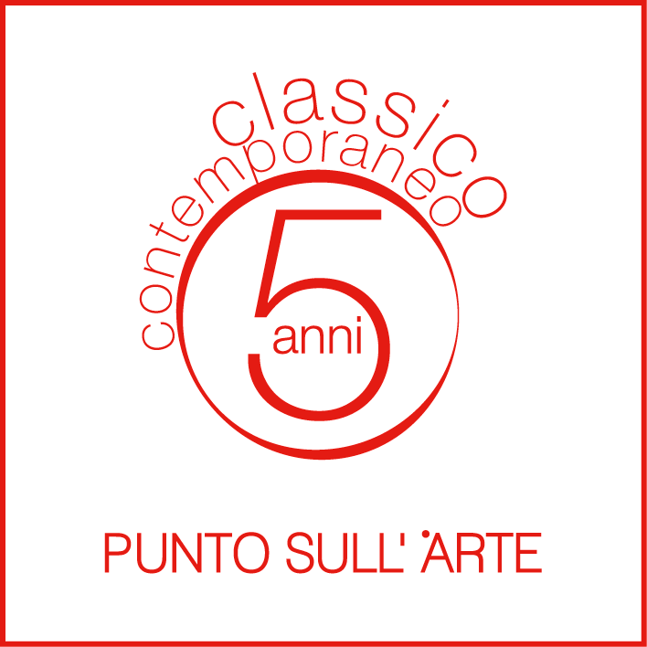

PUNTO SULL’ARTE.
CINQUE ANNI - CLASSICO CONTEMPORANEO

Opening: SATURDAY 19th NOVEMBER 2016, from 6 to 9 pm
Dates: 20 November – 30 Dicember 2016
Location: PUNTO SULL’ARTE, Viale Sant’Antonio 59/61, Varese 0332 320990 I info@puntosullarte.it
Visiting Hours: Tuesday – Saturday: 10 am-1 pm and 3-7 pm. Sunday: 3-7 pm

The PUNTO SULL’ARTE Gallery is turning five years old and it is going to celebrate it on Saturday November 19th from 6 to 9 pm by opening, exactly five years after its first vernissage – held on 19th November 2011 – an exhibition aimed at narrating the Gallery’s story. Not just a collective exhibition gathering the artists who grew together with the Gallery and are promoted and supported by it, but a true declaration of intents from a reality which, within the complex and varied panorama of contemporary art, married an expressivity deeply rooted within tradition, a pictorial (or sculptural) discourse which yet being contemporary and present loves to compare with ancient art and with a recognizable (and recognized) concept of beauty. Gathering the best of young Italian art, yet maintaining a focus abroad (Spain, South America, Sweden, USA), the Gallery takes stock of its path by retracing it per themes: from LANDSCAPE, both the countryside and metropolis (with Luca Gastaldo, Jernej Forbici, Andrea Mariconti, Arcangelo Ciaurro, Marika Vicari, Daniele Cestari, Matthias Brandes, Matteo Massagrande and Michele De Lucchi) to FIGURE, painted and three-dimensional, represented trough the sharpness of ancient art or evocative and almost abstract vibrations (here come Claudia Giraudo, Federico Infante, Ilaria del Monte, Liliana Cecchin, Pietro Scampini, Dolores Previtali, Nicola Biondani, Matteo Pugliese and Alex Pinna). From the intriguing symbolism of ANIMAL WORLD (Massimo Caccia, Gabriele Buratti, Johannes Nielsen, Matthias Verginer, Mario Branca e Alice Zanin) to the endless facets of STILL LIFE (Ottorino de Lucchi, Paolo Quaresima, Maria Teresa Gonzalez Ramirez, Alberto Bortoluzzi, Alberto Magnani and Annalù). Up until a unique interpretation of ABSTRACT (Tomàs Martínez Suñol, Paola Ravasio, Antonio Pizzolante, Jill Höjeberg and Marica Fasoli).

Artisti: ANNALÙ, BIONDANI, BRANCA, BRANDES, BORTOLUZZI, BURATTI, CACCIA, CECCHIN, CESTARI, CIAURRO, DEL MONTE, DE LUCCHI, FASOLI, FORBICI, GASTALDO, GIRAUDO, GONZALEZ RAMIREZ, HÖJEBERG, INFANTE, MAGNANI, MARICONTI, MASSAGRANDE, NIELSEN, PINNA, PIZZOLANTE, PREVITALI, PUGLIESE, QUARESIMA, RAVASIO, SCAMPINI, SUÑOL, VERGINER, VICARI, ZANIN.

